Difference between StringBuffer and StringBuilder

Java provides three classes to represent a sequence of characters: String, StringBuffer, and StringBuilder. The String class is an immutable class whereas StringBuffer and StringBuilder classes are mutable. There are many differences between StringBuffer and StringBuilder. The StringBuilder class is introduced since JDK 1.5.

A list of differences between StringBuffer and StringBuilder are given below:

|  |  |  |
| --- | --- | --- |
| **No.** | **StringBuffer** | **StringBuilder** |
| 1) | StringBuffer is *synchronized* i.e. thread safe. It means two threads can't call the methods of StringBuffer simultaneously. | StringBuilder is *non-synchronized* i.e. not  thread safe. It means two threads  can call the methods of StringBuilder simultaneously. |
| 2) | StringBuffer is *less efficient* than StringBuilder. | StringBuilder is *more efficient* than StringBuffer. |

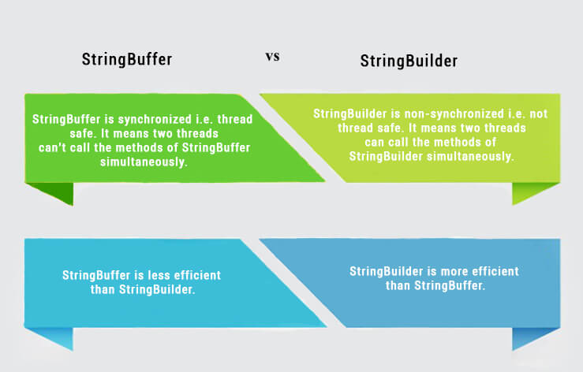

StringBuffer Example

1. //Java Program to demonstrate the use of StringBuffer class.
2. **public** **class** BufferTest{
3. **public** **static** **void** main(String[] args){
4. StringBuffer buffer=**new** StringBuffer("hello");
5. buffer.append("java");
6. System.out.println(buffer);
7. }
8. }

hellojava

StringBuilder Example

1. //Java Program to demonstrate the use of StringBuilder class.
2. **public** **class** BuilderTest{
3. **public** **static** **void** main(String[] args){
4. StringBuilder builder=**new** StringBuilder("hello");
5. builder.append("java");
6. System.out.println(builder);
7. }
8. }

hellojava

Performance Test of StringBuffer and StringBuilder

Let's see the code to check the performance of StringBuffer and StringBuilder classes.

1. //Java Program to demonstrate the performance of StringBuffer and StringBuilder classes.
2. **public** **class** ConcatTest{
3. **public** **static** **void** main(String[] args){
4. **long** startTime = System.currentTimeMillis();
5. StringBuffer sb = **new** StringBuffer("Java");
6. **for** (**int** i=0; i<10000; i++){
7. sb.append("Tpoint");
8. }
9. System.out.println("Time taken by StringBuffer: " + (System.currentTimeMillis() - startTime) + "ms");
10. startTime = System.currentTimeMillis();
11. StringBuilder sb2 = **new** StringBuilder("Java");
12. **for** (**int** i=0; i<10000; i++){
13. sb2.append("Tpoint");
14. }
15. System.out.println("Time taken by StringBuilder: " + (System.currentTimeMillis() - startTime) + "ms");
16. }
17. }

Time taken by StringBuffer: 16ms

Time taken by StringBuilder: 0ms